

**National University Of Science and Technology**

Assignment # 3

Programme : AE-01 (Aerospace Engineering)

**Name : Fiza Ali**

**CMS ID : 454685**

**Subject Code : AE-103**

**(Engineering Drawing And Graphics)**

**Professor : DR. Irfan Zafar**

**Submitted To : Ma’am Laiba Waheed**

**Procedure to make Isometric Drawing on Autocad:**

1. **Set Up Layers:**

Create layers for different elements of the drawing such as "Box Outline," "Box Interior," and "Dimensions."

Assign different colors and names to each layer for clarity such as hidden lines, continuous lines and center line.

1. **Draw the Box Outline:**

Use the Line command to draw the outline of the box in the "Box Outline" layer.

Start by drawing the bottom rectangle.

Then draw lines for the sides, ensuring they're at the desired angles and required length for the tilt.

1. **Use different Commands according requirement:**

* Line(L): Draws straight line segments between two points.
* Circle (C): Creates a circle by specifying a center point and radius or diameter.
* Rectangle (REC): Draws a rectangle by specifying two diagonal corner points.
* Arc (ARC): Draws an arc by specifying a center point, start point, and endpoint.
* Move (M): Moves objects from one location to another.
* Copy (CO): Copies objects from one location to another.
* Rotate (RO): Rotates objects around a base point.
* Scale (SC): Changes the size of objects proportionally.
* Trim (TR): Trims objects to meet the edges of other objects.
* Extend (EX): Extends objects to meet the edges of other objects.
* Mirror (MI): Creates a mirrored copy of selected objects.
* Offset (O): Creates parallel copies of lines, polylines, or arcs at a specified distance.
* Array (ARRAY): Creates multiple copies of objects in a pattern.
* Dimension (DIM): Adds dimensions such as linear, radial, angular, and ordinate to the drawing.
* Text (TEXT): Adds single-line or multiline text to the drawing.
* Fillet (FILLET): Round the corners of box according to desired radius.

1. **Add Dimensions:**

Switch to the "Dimensions" layer.

Use the DIM command to add linear dimensions for the length, width, and height of the box.

Ensure that the dimensions are aligned properly and placed in an organized manner.

1. **Adjust Layers and Properties:**

Review your drawing and ensure that all elements are on the correct layers.

Adjust line types, colors, and other properties as needed for clarity and presentation.

1. **Finalize and Save:**

Review the drawing to ensure everything looks correct.

Save your work.

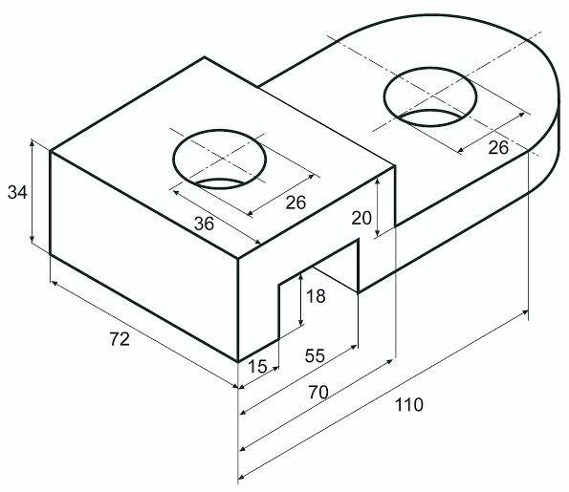**Question:01**

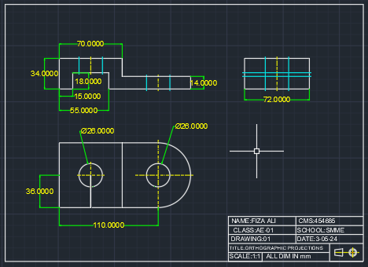**Solution:**

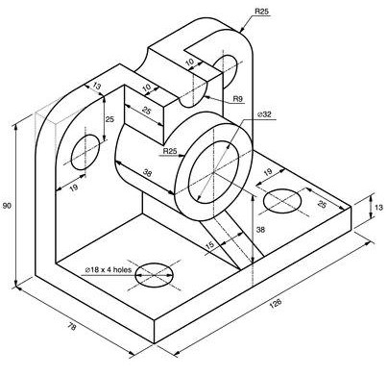**Question:02**

**Solution**

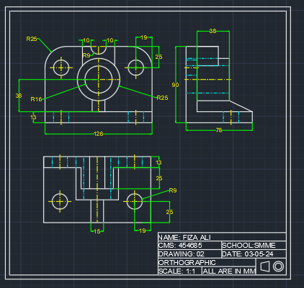

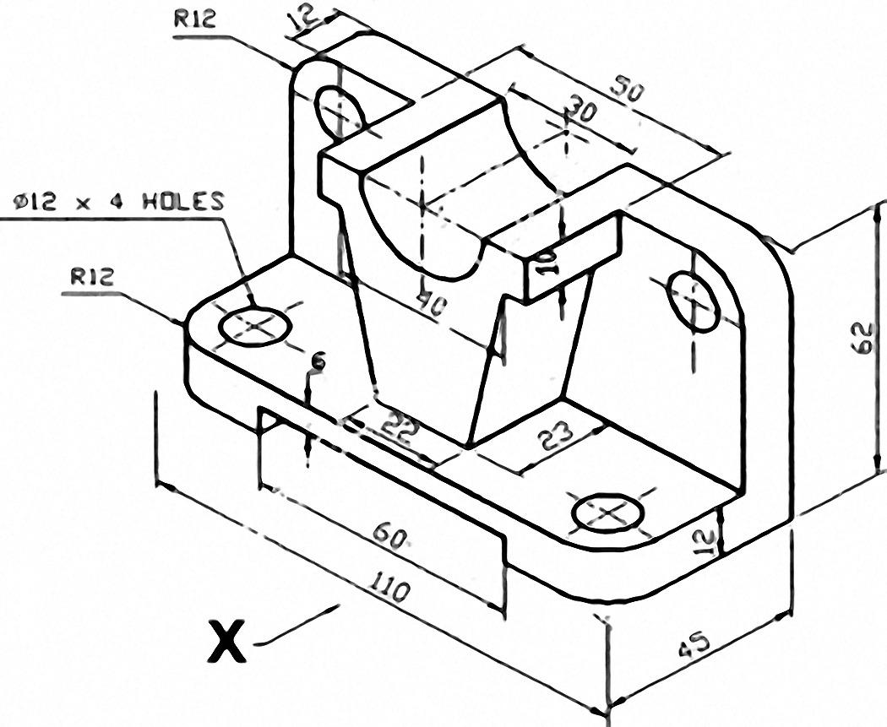**Question:03**

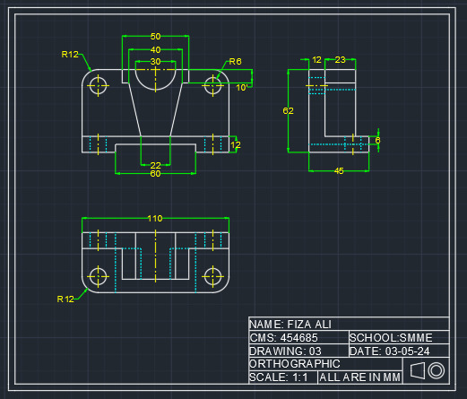**Solution:**